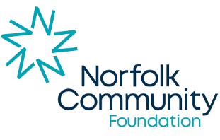
Photo competition 2026 entry form
Name: | Click or tap here to enter text.
Organisation name: | Click or tap here to enter text.
Phone number: | Click or tap here to enter text.
Email: | Click or tap here to enter text.
How did you find out about the competition? | Click or tap here to enter text.
Tell us about the pictures you’ve submitted: | Click or tap here to enter text.
I confirm that we have received funding from Norfolk Community Foundation in the past 18 months: |  | ☐
I confirm that I have secured the relevant consents from the individuals in this image: |  | ☐
I have read and agree to abide by the competition terms and conditions (see Norfolk Community Foundation’s website) |  | ☐

Signed: | Click or tap here to enter text.
Date: | Click or tap to enter a date.

Please email your form and entries to us at shinebrighter@norfolkfoundation.com.

