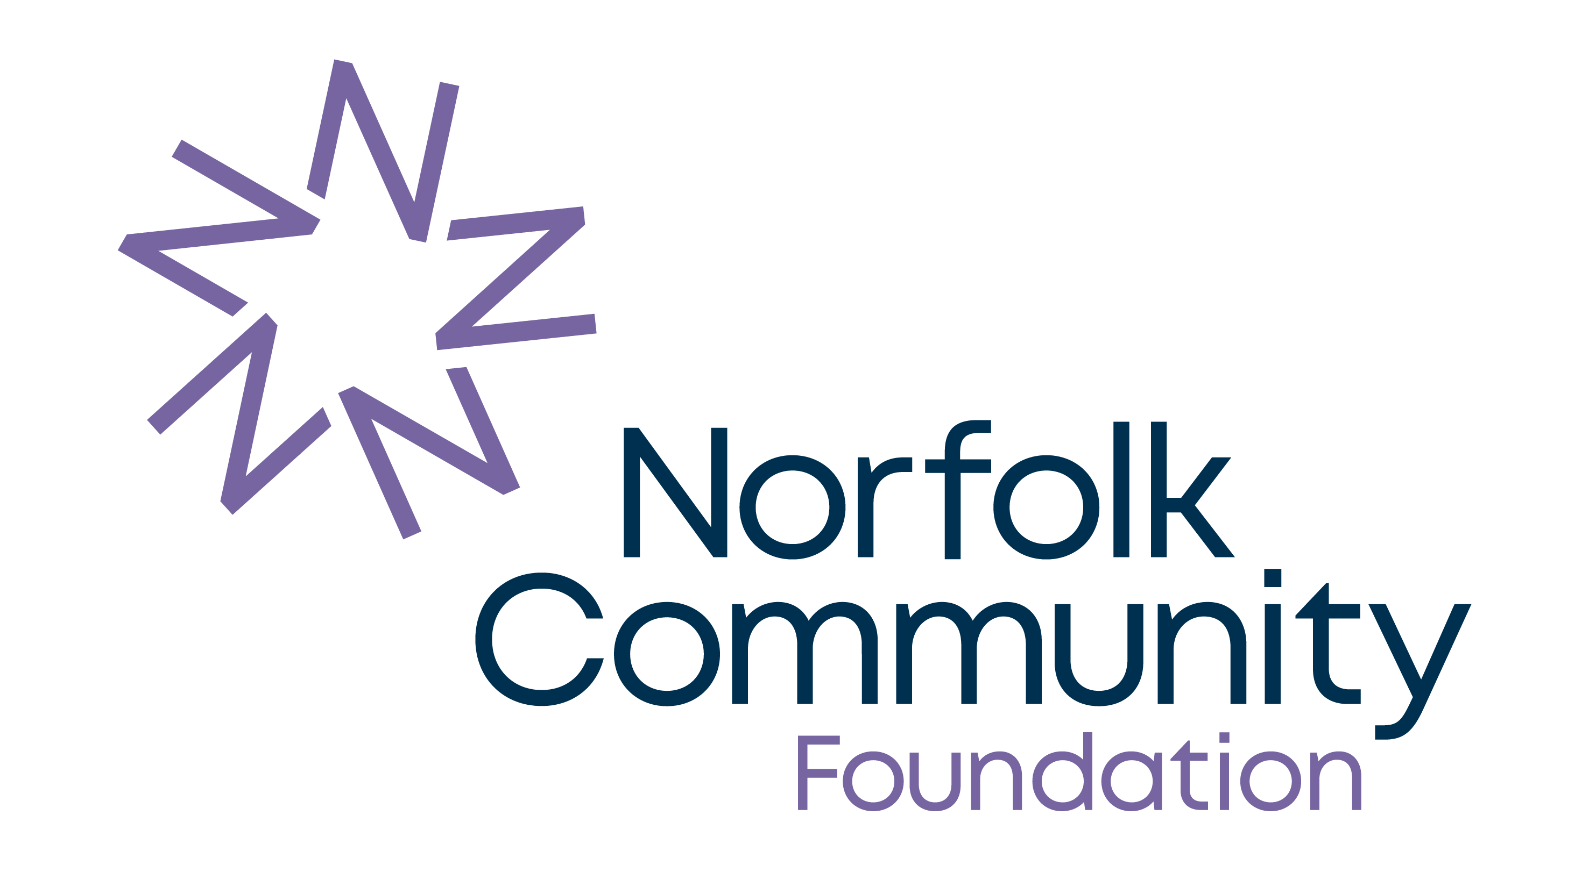
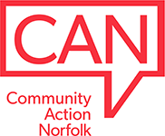

MICROGRANTS PROPOSAL FORM

Name of group (if applicable):
Name of person filling out form: | 1. | Email address:
Name of person filling out form: | 1. | Tel. number:
Please provide the names of at least two other people involved in your group. | 2.
 | 3.
 | 4.

Please tell us a bit about your group, where you’re based, what kind of activities you run (or would like to run) and how you have identified a need for this activity in your community.

Please cross (x) if your group already has any of the following in place:
 | Governing Document (e.g. a constitution) |  | Annual Accounts
 | Equalities Policy / Statement |  | Bank account in the name of your group
 | Safeguarding Adults Policy & Procedures |  | Safeguarding Children Policy & Procedures

If your group has been running for more than 12-months, does your annual income exceed £25,000?

Yes |  | No |  | N/A

Please tell us about the support you are looking to receive from the Microgrants Fund.
This could be the type of organisation you hope to become, the policies you are aiming to adopt, or the insurances and training that are required for your group’s activity. If you are unsure, please provide as much information as possible and we will do our best to advise.
How much would you like to apply for? The value of your request will likely depend on the support you are looking to receive. If you have an understanding of any costings for the support you would like to receive, please include this here. If not, this is something that can be worked out during your discussion with Community Action Norfolk or NCF.
If you can, please tell us where you heard about the Microgrants Fund.

Declaration

- I am authorised to make the application on behalf of the above group.
- I certify that the information in this proposal is correct.
- If any of the information provided changes, I shall notify Norfolk Community Foundation as soon as possible.
- I give permission for Norfolk Community Foundation to record the information in this form electronically and to contact my group by telephone, e-mail or post in order to process this proposal and arrange a follow up meeting.
- I understand that the information given in this application form will be shared with the NCF team who will form the decision-making panel
- I understand that decisions made by the appointed decision-making panel are final.
- I accept that any grant awarded by NCF must be used in accordance with the good practice set out in our Standard Terms & Conditions of funding, which apply throughout the grant term.
- I accept that any grant offer may be subject to additional terms and conditions that must be accepted prior to the payment of the grant and must be adhered to throughout the grant term.

* By completing this form, you are confirming the declaration above and also agreeing to Norfolk Community Foundation retaining the personal and organisational data you have provided on our database. This information will be used to help review and assess your proposal, to administer and monitor any grant awarded, and as part of any publicity or other grant related activity undertaken by Norfolk Community Foundation. Read our full Privacy Notice at www.norfolkfoundation.com/privacy-policy

Please return this form by email to grants@norfolkfoundation.com, or by post to Norfolk Community Foundation
First Floor, Carmelite House, 2 St James Court, Norwich, NR3 1SL. If you have queries, please contact Lizzi Barker on 01603 623958, email: lizzibarker@norfolkfoundation.com.

