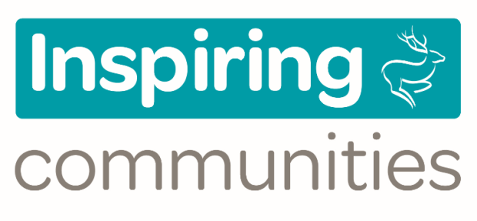 | 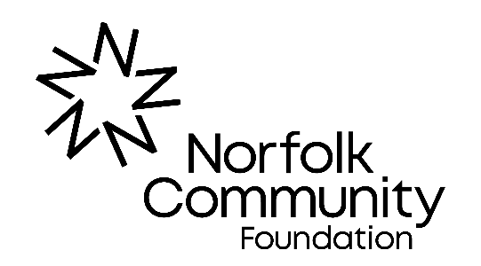

Breckland Council Inspiring Communities Funding 2022/23
Guidance Notes
This guide has been designed to help you when applying to Norfolk Community Foundation for Breckland Council Inspiring Communities Funding. It details our expectations of applicants, the processes involved and the criteria that need to be met. It is designed to help you successfully secure funding for your project and follow best practice principals of project development.
Please do not fill in an application until you have read this guide.
How much is available?
Breckland Council is providing £120,000 per annum which will be awarded over four funding rounds (£30,000 per round).
How much money can I apply for?
You can apply for a maximum grant of £5,000, up to a maximum of 50% of your total project costs.
How to apply
Applications are made via Norfolk Community Foundation’s website www.norfolkfoundation.com If, for any reason, you are unable to access the application form online, please contact Norfolk Community Foundation on 01603 623958 to discuss your options.
Who can apply?
- Voluntary and/or community organisations operating in and benefitting the Breckland area and residents
- Parish or Town Councils from within the Breckland area
- Schools from within the Breckland area, looking to provide community activity*
- Not for profit social enterprise or community interest companies**
- Church/PCC groups for secular projects
Remember - the organisation submitting the application must be the same as the organisation receiving the funding.
* Applications from schools are welcomed but we cannot fund activities or services that schools have a statutory obligation to provide. We cannot fund curriculum based activities or activities taking place during the school day. However, we can fund projects that are based on school grounds that take place for the benefit of the wider community (e.g. before or after the school day or during the holidays).
** Social Enterprises/CICs are able to apply but such organisations should first read Norfolk Community Foundation’s guidance to ensure you meet our eligibility requirements.
What we will consider funding
Community projects that can demonstrate that they align with Breckland Council's Inspiring Communities outcomes which are:
- To lead the recovery from COVID-19, supporting all Breckland's communities.
- To address vulnerability and work with the most disadvantaged members of our communities to improve their life chances.
- To enhance the health and wellbeing of Breckland's residents as part of Norfolk's Integrated Care System and by providing excellent leisure facilities and activities.
What we can’t fund
- Organisations that are not appropriately constituted
- Activities that take place or costs that are incurred before we confirm our grant offer
- Applications from groups who have not consulted their Breckland Ward Member
- Applications that do not clearly align with one of the Breckland Council outcomes.
- Contingency costs
- VAT that you can reclaim
- Fundraising activities – for example paying for a selection of raffle prizes for a fete
- Repayment of loans or interest repayments
- Projects or activities that the state has a legal obligation to provide
- Projects that cannot be maintained because of high ongoing costs or the need for specialist skills
- Projects that require planning permission but do not yet have it.
NOTE: Applications for funding towards highways improvements or Parish street lighting will not be considered unless exceptional circumstances can be demonstrated, and applicants can evidence that they have exhausted all other options for funding. It is recommended that groups interested in submitting such applications should contact the Breckland Council Communities team (tel: 01362 656870) before submitting an application via Norfolk Community Foundation.
Who assesses my application?
Norfolk Community Foundation will review your application and will contact you if they have any questions. Applications deemed incomplete will be discussed with the applicant and any necessary improvements or recommendations offered by NCF will need to be actioned by the applicant before a resubmission can be made. Once we are happy your application is complete, we will forward this through to Breckland Council for a decision.
The decision process
The Fund will operate four funding rounds over 2022/23. The deadlines for applications for these rounds are:
- Friday 17 June (decisions expected in July)
- Friday 16 September (decisions expected in October)
- Friday 9 December (decisions expected in January)
- Friday 10 February 2023* (decisions expected in March) *please note the deadline for this round has been brought forward by one month
Applications which are submitted without all of the required information will be deferred until they are complete and may not therefore receive a decision in line with the timescale above.
Informing you of the decision
Once a decision is reached Norfolk Community Foundation will advise you of the decision. It will also advise you of any additional conditions that apply to your grant award. Please note, our standard terms and conditions NCF Standard Terms and Conditions apply to all awards.
Promoting your project and funding award
One of the conditions of receiving a grant requires you to contact the Breckland Council Community team at Community@breckland.gov.uk in order to coordinate any subsequent press coverage where you will be obliged to acknowledge the financial input from Breckland Council and provide photographs of the project as it develops.
Starting your project
In general, the grant can be paid up front but we reserve the right to vary this on a case by case basis. All projects and grants must be claimed and completed within 1 year of the offer being accepted, unless there are extenuating circumstances which would need to be agreed in writing with Norfolk Community Foundation on an individual basis.
Monitoring and finishing your project
During the course of your project you may be asked to complete an interim monitoring report to keep us updated on the progress with your project with a final report due on completion of the project so that we can see how successful your project has been and what benefits have been achieved as a result of the grant. We may visit or telephone you to check on the project at any time.
Please note: Once your organisation has received an Inspiring Communities grant from Breckland Council, you cannot re-apply for this funding again within the same financial year, even if it is for a different project. If you hold a grant from the previous year’s Inspiring Communities programme you must have spent this and have satisfactorily met all our monitoring requirements before applying again.
This does not prevent you from applying to other (non Breckland District Council) funding streams operated by Norfolk Community Foundation.
What documentation to include with your application
Before completing an application form, please make sure you can supply us with the following:
- A copy of your constitution of governing document
- A copy of your most recent annual accounts (or current financial statement if your organisation has been operating for less than a year)
- A copy of a recent bank statement
- Evidence that you have consulted with the community
- Evidence that you have match funding for the project
- A copy of relevant safeguarding policies if your project involves work with children or vulnerable adults
- Copies of quotes, estimates or other evidence of costs if applying for funds to pay for equipment, building works, services or similar (preferably three for each service/product)
- For projects involving building works or installations of e.g. of sports/play equipment - evidence that planning permission/ other relevant permissions are in place or that they are not required
- A copy of your equal opportunities policy/statement
If you have applied to Norfolk Community Foundation previously we may hold some of these documents already and you need only supply those which have been updated or which are specific to this application (e.g. quotations or confirmation of match funding).
Frequently asked questions
Q | What are the deadlines for sending in an application form?
A | - Friday 17 June (decisions expected in July)  - Friday 16 September (decisions expected in October)  - Friday 9 December (decisions expected in January)  - Friday 10 February 2023 (decisions expected in March)
Q | I am unable to apply online, how else can I apply?
A | Please contact Norfolk Community Foundation who will discuss options with you.
Q | We do not have all the essential documents in place, what should we do?
A | We suggest you seek advice from an agency such as Voluntary Norfolk or Community Action Norfolk in order to get some help and guidance in developing any missing policies or other documents. Please do not apply until you can meet our requirements.
Q | If my application is unsuccessful, can I apply again?
A | If you are able to address any feedback in the decision letter then a re-application is possible. However, we would recommend that you talk to Norfolk Community Foundation before you start a new application.
Q | Can I apply for more than one year’s funding?
A | No, the funding is for one year only.
Q | We still need to raise other funding for our project, when should we apply?
A | Generally, we would expect the other necessary match funding to be in place before an application is made. You may wish to discuss the specifics of your funding need with NCF before starting an application
Q | What are the main problems you find with applications?
A | Common problems include:  - providing answers that are too brief,  - not providing all of the required documents,  - not evidencing capital costs clearly,  - not making the project’s relevance to Breckland Council’s outcomes clear,  - applying for grants at too early a stage without other confirmed funding in place.
Q | Can I speak to a Grants Officer before starting an application?
A | Yes, we encourage this. Please phone us on the number at the end of this document.

Data protection and Freedom of Information
The information you give in your funding application is used to assess your application and will be shared with the grant panel members and relevant officers in both Norfolk Community Foundation and Breckland Council. If your project is successful the information will be kept for seven years.
Fraud
If you provide false or inaccurate information in your application or at any point in the life of any grant and fraud is identified, we will provide details to fraud prevention agencies, to prevent fraud and money laundering.
Freedom of Information
Please be aware of the Freedom of Information Act 2000, which means that members of the public have the right to request information from Breckland Council. This could include information it holds from third parties, for example, grant applicants. If Breckland Council receives a Freedom of Information request, as long as there are no exemptions, it must comply, but would inform you first. Please state on your application form if you think that the information in your application should not be released as part of a Freedom of Information request.

If you have any questions please contact:
Norfolk Community Foundation
St James Mill, Whitefriars,
Norwich NR3 1TN
Tel: 01603 623958
Email: grants@norfolkfoundation.com

