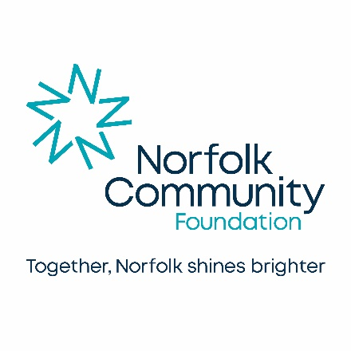
Dormant Client Funds and Unclaimed accounts

Professional firms are required to return balances on client accounts promptly where there is no reason to retain them. It can be in the interest of your firm to ensure that money, which might otherwise remain inactive and subject to yearly audit, goes directly to charitable causes. Norfolk Community Foundation has established a number of funds as a result of dormant client accounts or unclaimed client monies.
Further guidance about Dormant Client Funds can be found on the website of the Solicitors Regulation Authority.

The Charity Commission acknowledges that community foundations have a reputation for the effective management of charitable funds in order to maximise their impact at local level.

To find out more please contact the Norfolk Community Foundation on 01603 623958
St James Mill, Whitefriars, Norwich, NR3 1TN
Follow us on twitter @NorfolkCF and Facebook
Registered Charity Number: 1110817 Company Registration Number: 05234236

